 | Sun, Sep 28, 2025, 6:47 PM
  Kevin Kelleher, Jr. <kevkelljr@yahoo.com>
to me, Jim, Brent, Connor, Aidan, Don, Craig, Joshua, Peter, Steve, Fran, Spencer, Liam, Jim, Gabe, John, Chris, Andy, Brian, Paul, Kyle, Brett, Barry, Dick, Colin, Rob, Steve, Tom, Tim, Lee, Mike

Happy Sunday boys,
On the long drive home on the ‘Monday After’ every year, so many questions and thoughts start running thru our heads. You reflect on those shots you want back, the matches you should have won, or those last 10 truck beers that are currently causing your diarrhea.
And whether you won or lost, you just can’t help but think towards next year. Questions like: What team will I be on? Who will I play against? Will I have to play with Dick Lenfest again?
Well, the draft is over. The Irish Village Idiots are ready to go. And great news, Lenfest is on the other team. So, we don’t have THAT to worry about.
All that is left to do now is to start announcing the Day 1 pairings!
Now, they say you can’t win the Cape on Day 1. But we Idiots refuse to accept that. Our first pairing includes a couple of razor sharp Cloutier family members ready start shaving some mooostaches down to size. Our #1 Idiot is a veteran southpaw from Ludlow Country Club with an impeccable cape record. This guy just wins. I’m sorry it’s almost not fair. We are talking about Paul Carr here guys.
Joining him is an athletic young sophomore Caper with great bloodlines who recently completed a botany class and picked up 4 new freshly minted strokes to boot. Here he is, back from Texas, fearless, and no longer intimidated by wood, Connor Cloutier.

Invest in those shaving cream futures. This bunch of Idiots runs with scissors. Staches are on the clock.

On Tue, Sep 30, 2025 at 7:42 AM Stephen Webster <weeberinwyben@gmail.com> wrote:
Sent video link to Ted Knight saying “Well, We’re Waiting……”

Not a bad start Junior. It’s clear that your creative writing skills definitely outshine your drafting skills. Not sure about the cheap shot at the expense of the Stache’s favorite Athletic Director, but I’m sure he’ll keep that one in his back pocket and will be driving over the Sagamore Bridge with a little extra incentive this year.

The Moostache’s Men have been preparing for their favorite trip of the year over the last week and I’ve already seen some pictures of quality facial hair being grown out by some team members. Keep it going boys!

We’ll be leading off against the Cloutier family Idiots with two seasoned Cape veterans. Our 1st Stache already has 5 Bag Tags in his trophy case and is looking to make it an even half dozen this year. His unflappable course demeanor travels well to the Cape and he’ll be looking to impress the true Moostache with his play over the weekend as he prepares to become a Moostache In-Law following a late October wedding; Mr. Tim (Lacey) O’Connor.

Playing with Tim is a guy who’s averaged close to 5 points/year over the last 3 Cape trips and his short game matches up with anyone’s on the trip. His steady game will play well in the Bramble format and we all know I can’t pronounce his last name, so we’ll just call him Josh Bal.
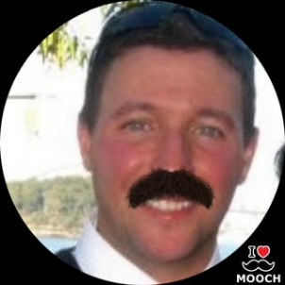

Next up for the Staches is a pairing that God used as his template when He decided to create the Bramble. The first golfer is as steady as they come; it doesn’t matter what the format is, which course we play or how low the Commish makes his handicap. This guy just keeps making points. And if that wasn’t enough, after golf he moonlights as a Bellhop at the Irish Village. The second half of this ideal pairing will be walking into Day 1 with a 21 handicap. He’s agreed to go along with Gabe Crane’s rule that anytime he gets a 2 (NET Hole in 1) on one of the five par 3’s we’ll be playing on Friday, he’ll buy the entire 19th Hole a round of drinks. Come thirsty boys! The Adam and Eve of Bramble golf, Lee Albertson and Donald Cloutier.
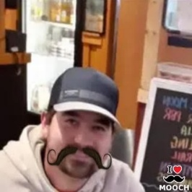
Back to you two Idiots…

 | Tue, Sep 30, 2025, 9:40 PM
  Stephen Webster <weeberinwyben@gmail.com>
to John, John, Connor, Jr., me, Jim, Brent, Aidan, Don, Craig, Joshua, Peter, Fran, Spencer, Liam, Jim, Gabe, Chris, Andy, Brian, Paul, Kyle, Brett, Barry, Dick, Colin, Rob, Steve, Tom, Tim, Lee, Mike

Impressive picks and photo shopping there Johnny. No altered (or any) pics of the Village Idiots here.
God may have inspired the Albertson/ Cloutier pairing but The Village Idiots have some divine inspiration of their own. The Idiot’s answer to the holy bramble pairing is none other than Fran Burrage and Steve Parrow. These are not your average idiots. Both players have some good Golfapalooza experience especially at the Cape. Both players have a history of taking a fair share of points from unexpecting opponents. I would be remiss if I didn’t mention that Fran has the coolest hair (I am jealous). Guaranteed to be a lot of laughs in this group.
Our next pairing for the Idiots are a little younger. These two players grew up together in Westfield and were on many of the same hockey, baseball and golf teams. They were even coached by our very own Commissioner on a few of them. I am pleased to announce our very own Spencer Cloutier and Liam Webster. They have played together many times, and their golf games complement each other very well especially for a bramble. LFG (with the Red Sox too!!).
You are up next oh unshaven ones.
 | Oct 1, 2025, 12:58 PM
  John Bonini <jbonini@westfieldbank.com>
to Stephen, John, Connor, Jr., me, Jim, Brent, Aidan, Don, Craig, Joshua, Peter, Fran, Spencer, Liam, Jim, Gabe, Chris, Andy, Brian, Paul, Kyle, Brett, Barry, Dick, Colin, Rob, Steve, Tom, Tim, Lee, Mike

Totally agree on the LFG for the Sox Steve! That’s the first smart thing the Idiot Captains have said since Sunday. Great win! Interesting mix of old/old and young/young Idiots from you guys in those pairings.
The Moostache’s Men will counter the youngsters with a middle-aged Champion who has already pocketed 7 Bag Tags and has averaged an impressive 6.33 points over the last 3 Trips. This guy comes to play and this year he’s showing up with extra cash in his pocket, since he won’t have to be buying $40 Gin n’ Tonics at New Seabury, and with a chip on his shoulder after being dissed by Captain Idiot; the Stache’s favorite AD, Dick Lenfest.
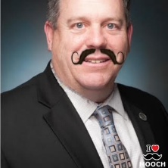
Dick will be paired with a southpaw young gun who has the uncanny ability to hit his 5-wood anywhere between 90 yards and up to 250 yards. He’s also been rolling the ball on the greens as well as anyone in the League this year and will already have cracked his first beverage of the trip pre-7:00 AM on the Friday drive down; Mr. Andy Hess.
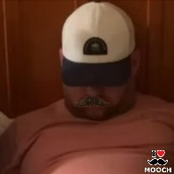
Next up for the Staches is a guy who just recently has been cleared from concussion protocol after surviving a horrific crash in a luggage cart driven by Bellhop Albertson during last year’s final night festivities. He’s the straw that stirs the drink, not only for our League, but for this entire trip as well; the Commish, Deni Cloutier.
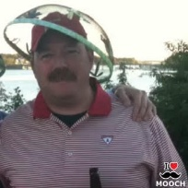
Going by the old adage, ‘If you can’t beat `em, join `em’, Deni will be playing with a guy who’s had his number in a bunch of Cape matches over the last 20+ years. He holds the all-time record for Bag Tags at 8 and will be looking to extend that record this year. Similar to Prince, Eminem and Madonna, the man who only needs one name, Crockett.
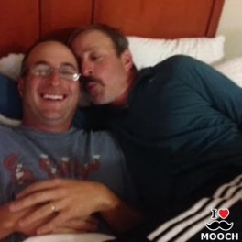

 | Wed, Oct 1, 2025, 3:08 PM
  Kevin Kelleher, Jr. <kevkelljr@yahoo.com>
to Stephen, John, John, Connor, me, Jim, Brent, Aidan, Don, Craig, Joshua, Peter, Fran, Spencer, Liam, Jim, Gabe, Chris, Andy, Brian, Paul, Kyle, Brett, Barry, Dick, Colin, Rob, Steve, Tom, Tim, Lee, Mike

Good afternoon esteemed Idiots....and all you other sasquatches.

Deni/Crockett is an interesting pairing. I guess this must be an 'if you can't beat him, join him' partnership of sorts. Hopefully, Crockett doesn't have to carry Deni's head around in a wheel barrel all day like he usually does. It gets heavy as you know. And these guys are gonna need all of their energy for what's to come.

This next pairing has a long history together. 20+ years ago, they won their first ever Cape event on Day 1 of their 1st trip and have usually won when paired together since. The first of this pairing is another usual Thursday arrival who is coming off the DL and now ready to get back into the swing of things. I have no doubts he'll pick up where he left off. Here he is, El Presidente, Mr. Barry Maloney.

Joining him is a quite possibly the most handsome golfer we have on this trip. Honestly, he's just an all-around impressive lad of quite some renown. We're talking about the seagull himself, Capt. Kelleher.

Now. Those match ups are cute and all but here and now is when this shit starts to get real yo. Let's get right down to it. The time for playing is done. After announcing this pairing there won't be another moosquatch sighting for the rest of the weekend.

Our first guy is fresh off a 37 playoff round and heating up at just the right time. He's a former winning captain...hell he might as well be promoted to general at this point. Mr. best in family, Aidan Dunn.

Joining him is another former winning captain, and the now current reigning Points per Cape Trip leader. I mean, just as I type these accolades it's almost comical how unfair this is. We're talking about Brett 'the Barber' Dooley.

Oops, I seemed to have just dropped my mic. Goodbye.

 | Thu, Oct 2, 2025, 11:43 AM
  John Bonini <jbonini@westfieldbank.com>
to Jr., Stephen, John, Connor, me, Jim, Brent, Aidan, Don, Craig, Joshua, Peter, Fran, Spencer, Liam, Jim, Gabe, Chris, Andy, Brian, Paul, Kyle, Brett, Barry, Dick, Colin, Rob, Steve, Tom, Tim, Lee, Mike

I see what you did there Junior, pairing up last year’s two winning Captains. Interesting strategy.

The Moostache’s Men will counter that with a twosome led by another young southpaw who absolutely bombs the ball off the tee and judging from the scores he’s been putting up most recently in the Chuckin’ Doors League, he’ll be heading to the Cape on a heater. Our biggest challenge with him will be to make sure he gets to sleep before 4:00 AM every night, so Captain Lacey will be stationed outside his room on a nightly basis enforcing a 10:30 PM curfew. I’m hoping he’s got a strong back to carry his partner around the course for the day, Chris Sullivan.
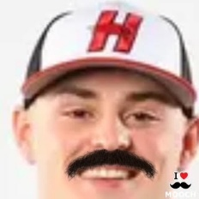
Chris will be playing with me. Sorry about that Christropher. I’ll buy the beers!
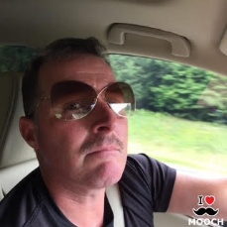
Next on the tee for the Staches will be another pairing that perfectly fits the Commish’s new Bramble format. The first guy is a newlywed and we’re hoping he’s able to avoid the trappings of marriage and this won’t be the last Cape Trip of his life. Just don’t take any advice from our old friend Jeremy Tanguay. He’s also a guy I want on our team just in case we get into a bench clearing brawl with the Idiots because I know he’ll be the first man in. He’s solid off the tee and his game travels well, as evidenced by the fact that he’s a perfect 2 for 2 in collecting Bags Tags. Let’s hope he keeps that unbeaten streak going this year; Kyle Murphy.
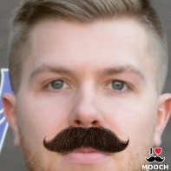
Joining Murph is a guy who’s taken a 3-year hiatus from the Trip but he’s coming back with a vengeance. As of yesterday, he was in second place on the team for facial hair growth, only behind Captain Moostache, with a full-blown beard. We appreciate the effort! Rumor has it that he’s tried to bride the Commish to play a Bramble format all 3 days, as he’s an absolute short game magician that will match this format perfectly; Brent Bean.
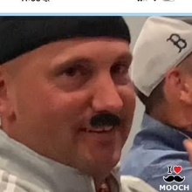
Please stay tuned for some more Idiotic pairings…

 | Thu, Oct 2, 2025, 7:03 PM
  Stephen Webster <weeberinwyben@gmail.com>
to John, Jr., John, Connor, me, Jim, Brent, Aidan, Don, Craig, Joshua, Peter, Fran, Spencer, Liam, Jim, Gabe, Chris, Andy, Brian, Paul, Kyle, Brett, Barry, Dick, Colin, Rob, Steve, Tom, Tim, Lee, Mike

Tough to follow John and Kev (after his mic drop). Even tougher will be trying to play golf against an opponent that looks like Freddie Mercury or Ron Jeremy (or even Magnum BM). Try to control your laughter before your swings Idiots.
Our next pick needs no introduction. The one and only Michael Terrell. Anyone who has played him knows that he is never out of a match and he never gives up. I witnessed this last year when I was partnered with him on the last day. He battled back to win the match from a seemingly insurmountable deficit on the front nine. It was amazing to watch.
Mike will be partnered with yours truly, Steve Webster. Steve was lucky enough to get a few points last year and is hoping to play even better this year as he has promised not to wear his helmet (on the course).
Next up for the Idiots is a man who has a name that sounds like a disease, Mr. Robert Atkocaitis. If winning was a disease, he would be in stage 4. We drafted him #1 and his record speaks for itself. Rob will be partnered with the man who has done so much for this trip, Tom Fanion. He puts the Irish Village in the Idiots. We all know him as the guy who feeds us like kings on Sunday, but anyone who played against him knows he doesn’t give up points too easily. It would be easier stiffing Deni your $5 side bet than getting a point off of him. The man has game. He can also bust balls with the very best of them and there are 32 experts on this trip. I’m glad that I don’t have to play these guys.
Back to the caterpillar lips. Go Sox!!

Well done Steve. Based on some of the preliminary facial hair I saw last night at Tekoa, The Moostache’s Men are well on our way to sporting some staches that will give our esteemed Captain’s stache a run for his money. Keep it growing boys! Now on to The Moostache’s Men’s final two pairings.

The team matching up against Rob and Tommy will be rekindling a partnership that led the 2009 Westfield Little League North All-Stars to a District 2 Championship as their Manager and star Shortstop. The first golfer was the Stache’s #1 overall draft pick and he’s coming off of last year’s trip where he collected his first Bag Tag of many to come. This guy is an absolute competitor who refuses to lose and his golf game is solid from tee to green. He’ll be looking to celebrate his second Bag Tag in a row with several Gin n’ Tonics in the parking lot on Sunday night, Colin Dunn.
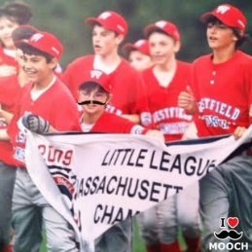
Colin will be matched with a golfer who absolutely dominated last year’s Cape Trip collecting a total of 8 out of a possible 9 points. He actually should be the one typing out this e-mail as a Captain right now, but somehow he got the Commish to let him off the hook so he could plan the 14 different wedding receptions he and his new bride had over the last 3 months. I’ve been told those are now finally all over and he can totally focus on his golf game; B Sul (no photo-shopped stache needed for this one; he came with his own).
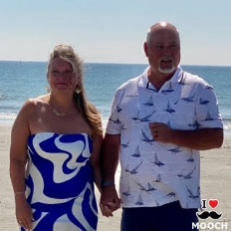

Batting cleanup for The Moostache’s Men is a twosome who absolutely dominated in their match last year when they were paired together. The elder golfer was a perfect 9 out of 9 in total points last year and he’ll be looking to keep that unbeaten streak alive during this year’s trip. He already has 7 Bag Tags to his credit and, if that wasn’t enough, we named our team after him; Mr. Pete Lacey.
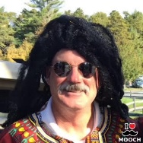
Pete will be joined by a guy who has averaged 5 ½ points/year over the last couple of trips and he has promised me that, unlike Murph and Tanguay, he’ll continue to make the Cape Trip even after he gets married this October. A guy whose bloodlines should afford him an uncanny ability to grow a solid stache for this Trip, Craig Lacey.
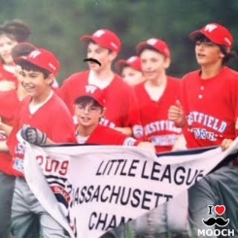
The Moostache’s Men out.

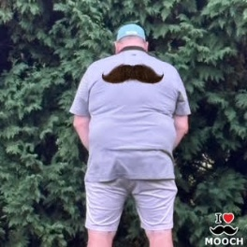
 | Fri, Oct 3, 2025, 11:12 AM
  Kevin Kelleher, Jr. <kevkelljr@yahoo.com>
to Stephen, John, John, Connor, me, Jim, Brent, Aidan, Don, Craig, Joshua, Peter, Fran, Spencer, Liam, Jim, Gabe, Chris, Andy, Brian, Paul, Kyle, Brett, Barry, Dick, Colin, Rob, Steve, Tom, Tim, Lee, Mike

My my, and just like that, the Staches have somehow already exhausted their pairings. But Idiots just don't know when to quit. We're still going strong over here.

Going Purebred Stache in the final pairing was an admittedly bold move that we can certainly appreciate. However, as Captain Stache prepares to give away his son this fall, he should also be prepared to give away 3 points next Friday as well.
Over here just sitting in our on deck circle is a monster pairing just waiting to pounce. This duo includes a couple of veteran ball strikers that will be able to feed off each other's games like a couple of middle aged cannibals. Both of these guys start their Golfapalooza countdowns the very moment the bag tags have been distributed. It's that type of focus and dedication that leads to victory.
Our first guy is a man who has been putting up solid numbers just about every year at the Cape. He's no stranger to success but does he just rest on his laurels? No way! He recently had his shoulder surgically enhanced just in preparation for this trip. Machines don't feel pressure and neither does Gabe 'the Terminator' Crane.
Joining the Terminator is my personal chauffer. He uses his blinker most of the time and he is extremely adept at driving around rotaries and over bridges named after Matt Damon characters. In his spare time, he also drives it into fairways, wins bag tags, and ideally Chuckin' Doors championships. Here he is....in the last pairing primarily so that I don't have to get up as early, Jimmy "the Van" Cloutier.
Let the Idiocy commence!
